CSCE 5290: NATURAL LANGUAGE PROCESSING
PROJECT PROPOSAL
Project Increment – 1

Project Title:
Sentiment Analysis on Live Tweets

Team Members:

Chaitanya Kumar Pothuraju - 11526614
Dinesh Chandra Sayana - 11519807
Kirankumar Danthala - 11514845

Github Link:

Table of Content

- PROJECT DESCRIPTION

GOALS AND OBJECTIVES
- MOTIVATION
- SIGNIFICANCE
- OBJECTIVES
- FEATURES

- REQUIREMENTS AND TOOLS

- DATASET

- IMPLEMENTATION FLOW

- PROJECT MANAGEMENT

- WORK COMPLETED

- WORK NEEDS TO BE COMPLETED

- REFERENCES

A) PROJECT DESCRIPTION:
Goals and Objectives:
- Motivation:
As text data is enormously increasing in the modern era and with the advent of social media, data is increasing with rapid pace this data contains public feelings, Opinions, review about products and many more emotions. So, we wanted to processes this text data and find out the sentiments from the text. This application also helps business to make decisions. which will help us learning the machine learning concepts as well as NLP.
- Significance:
Sentiment analysis is becoming vital tool for modern business in order to understand public emotions and there by taking business decision based on sentiment analysis. It also helps in finding brand reputation, product success rate, product dissatisfaction in the public.
- Objective:
The main objective of our project is to calculate the sentiments of tweet. We are considering for extraction of the following sentiments which are HAPPINESS, SAD, ANGRY, NEUTRAL.
- Features:
Our sentiment analysis model is based on LSTM and also tweets were sorted according to the geographical locations, our tool allows for easy deployment without disrupting the workflow. Aspect based sentiment analysis is also one of the features of our tool, this implies that for each written content, you may acquire various sentiment scores ranging from positive to negative. It's also incredibly configurable, so it'll be tailored just to your company's needs.

B) REQUIREMENTS AND TOOLS:
Numpy
Scikit-learn
Scipy
Nltk
Keras
TensorFlow for Logistic Regression, RNN and LSTM
Tweepy

C) DATASET:

https://www.kaggle.com/kazanova/sentiment140

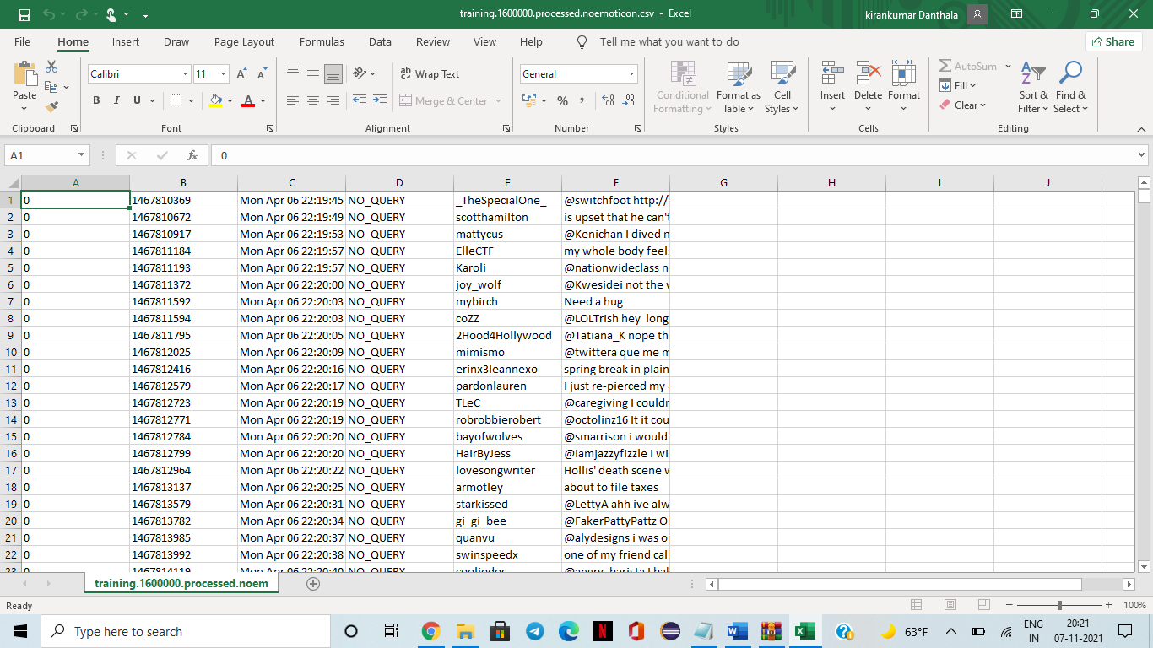

D) IMPLEMENTATION FLOW:

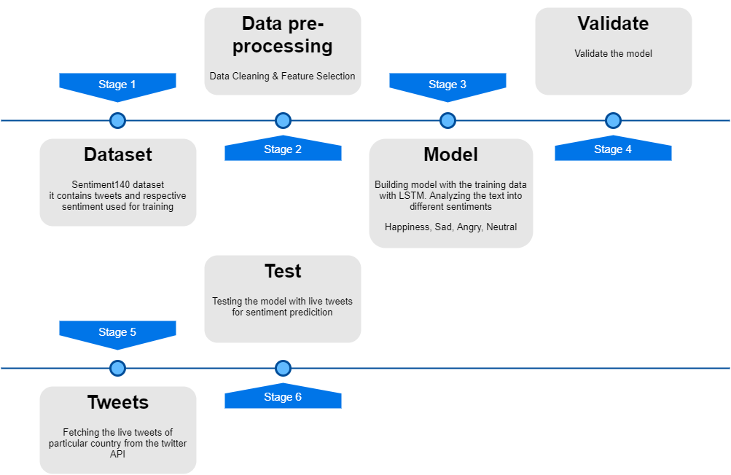

E) PROJECT MANAGEMENT:
- WORK COMPLETED:
Description:
In this step we have successfully created a developer account for the twitter user handle. The data set has been collected and, we also fetched the live tweets.

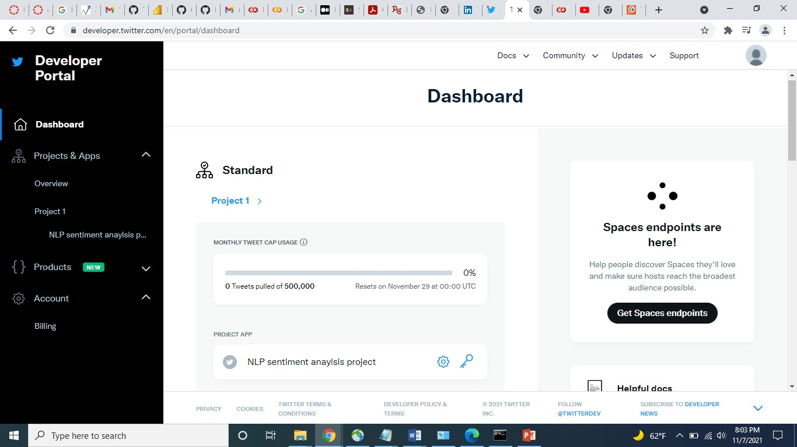

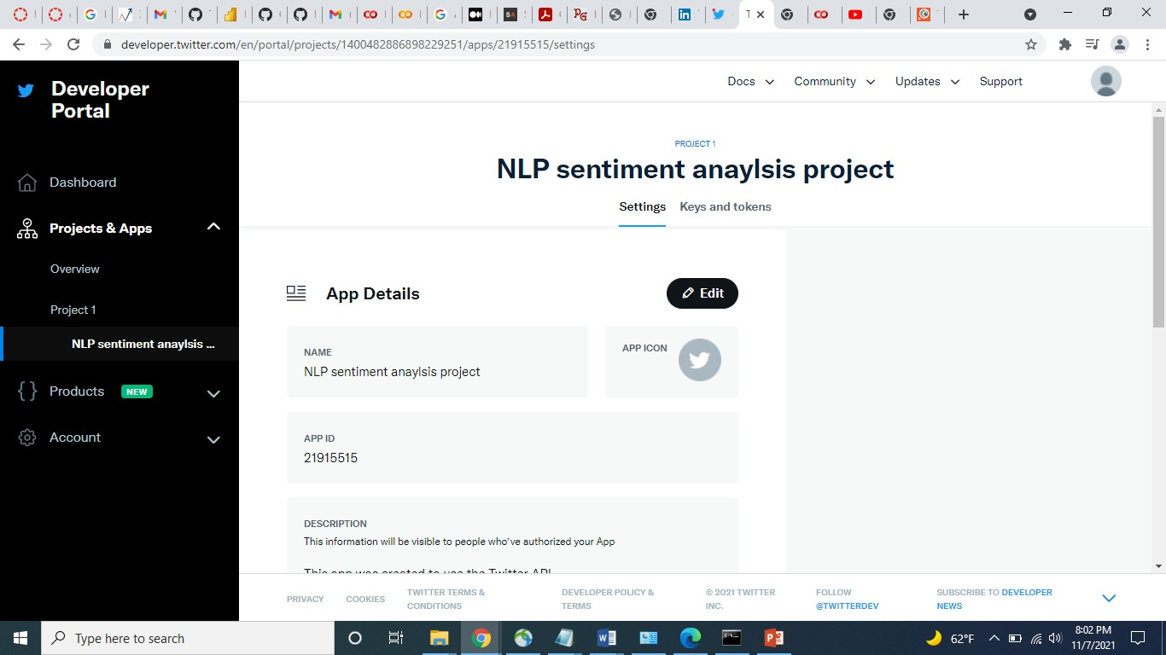

Fetching Live Tweets:
import requests
import os
import json

bearer_token= "#############################"

def bearer_oauth(r):
"""
Method required by bearer token authentication.
"""

r.headers["Authorization"] = f"Bearer {bearer_token}"
r.headers["User-Agent"] = "v2FilteredStreamPython"
return r

def get_rules():
response = requests.get(
"https://api.twitter.com/2/tweets/search/stream/rules", auth=bearer_oauth
)
if response.status_code != 200:
raise Exception(
"Cannot get rules (HTTP {}): {}".format(response.status_code, response.text)
)
print(json.dumps(response.json()))
return response.json()

def delete_all_rules(rules):
if rules is None or "data" not in rules:
return None

ids = list(map(lambda rule: rule["id"], rules["data"]))
payload = {"delete": {"ids": ids}}
response = requests.post(
"https://api.twitter.com/2/tweets/search/stream/rules",
auth=bearer_oauth,
json=payload
)
if response.status_code != 200:
raise Exception(
"Cannot delete rules (HTTP {}): {}".format(
response.status_code, response.text
)
)
print(json.dumps(response.json()))

def set_rules(delete):
# You can adjust the rules if needed
sample_rules = [
{"value": "cricket", "place_country" : "IN","tag":"T20 world cup"},

]
payload = {"add": sample_rules}
response = requests.post(
"https://api.twitter.com/2/tweets/search/stream/rules",
auth=bearer_oauth,
json=payload,
)
if response.status_code != 201:
raise Exception(
"Cannot add rules (HTTP {}): {}".format(response.status_code, response.text)
)
print(json.dumps(response.json()))

def get_stream(set):
response = requests.get(
"https://api.twitter.com/2/tweets/search/stream", auth=bearer_oauth, stream=True,
)
print(response.status_code)
if response.status_code != 200:
raise Exception(
"Cannot get stream (HTTP {}): {}".format(
response.status_code, response.text
)
)
for response_line in response.iter_lines():
if response_line:
json_response = json.loads(response_line)
print(json.dumps(json_response, indent=4, sort_keys=True))

def main():
rules = get_rules()
delete = delete_all_rules(rules)
set = set_rules(delete)
get_stream(set)

if _name_ == "_main_":
main()

Output:
{
"data": {
"id": "1457580259134554117",
"text": "If India bowl first, they need to chase down Namibia's target in 6 overs (36 balls) and if India bat first, then they must score 180 and win the match by 152 runs to reach home early. #Cricket"
},
"matching_rules": [
{
"id": "1457580189068759042",
"tag": "T20 world cup"
}
]
}
{
"data": {
"id": "1457580164938883072",
"text": "@ESPNcricinfo Shaheen's proved it they have a much better side of the World cricket although they face some bad behavior from other teams \ud83d\ude20\ud83d\udcaa"
},
"matching_rules": [
{
"id": "1457580189068759042",
"tag": "T20 world cup"
}
]
}
{
"data": {
"id": "1457580168034324482",
"text": "RT @daniel86cricket: If India bowl first, they need to chase down Namibia's target in 6 overs (36 balls) and if India bat first, then they\u2026"
},
"matching_rules": [
{
"id": "1457580189068759042",
"tag": "T20 world cup"
}
]
}
…..

- WORK NEEDS TO BE COMPLETED:
Description:
Most of the execution part which contains training, building and modifying data needs to be done and will do testing on the randomly generated tweets dataset.

F) REFERENCE:
- http://jestec.taylors.edu.my/Vol%2015%20issue%205%20October%202020/15_5_27.pdf

- https://d1wqtxts1xzle7.cloudfront.net/56761095/1524474367_23-04-2018-with-cover-page-v2.pdf?Expires=1636342284&Signature=Kpn3XY0c-j1CFN8USFqwODs5ImgQOiu7uqXRYlMoH0eM1dZ-y45zEg-3dOI-0mJAeRSmK3XbsStlxFTqTBthkWCfoor8hUQVpKXoX35LYPrWOZyCHC5ajBeadGr1RyMTxRUeBB4zCjG6Ng3lofiMKeLlPJ9vGQx3FY5W~xXoUGvho0W5jfKckNwG6nVfs4QxW-mOU~MUDd01yzGP5r06R8lWWEwgwhINOkrM-xvKAfSoV1~8y-9DnGRMGFGuX6wrf06qw7MWiuFXc1pLpjZWiNLB-iGoy23VpIqMQAi39TNZfeNZMadlfuXP4yZyLiXPRX-c4GSTJnPMMthlL1oDKg__&Key-Pair-Id=APKAJLOHF5GGSLRBV4ZA

